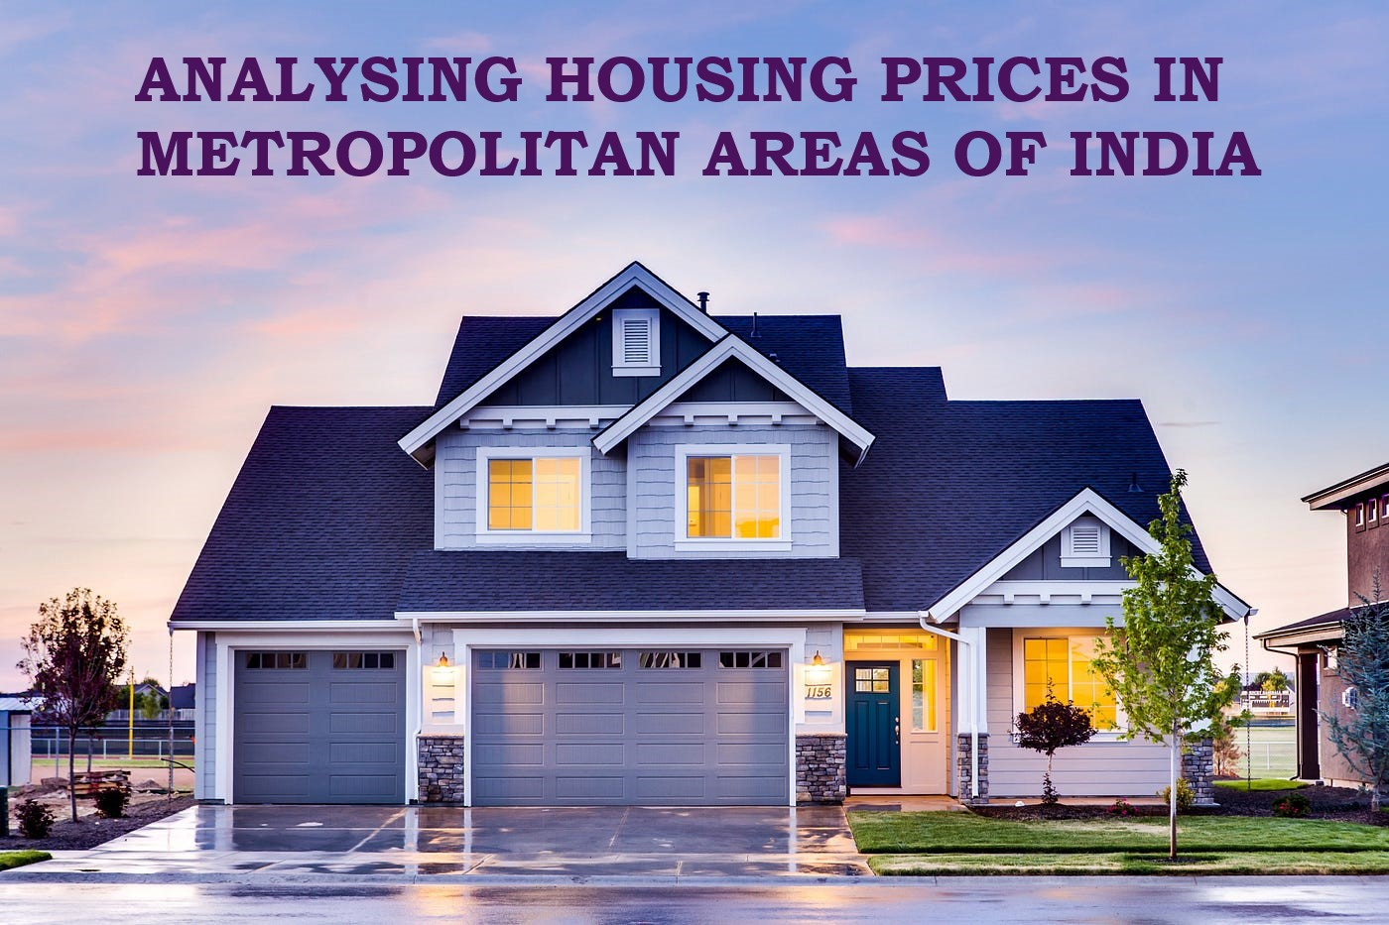

**1.INTRODUCTION**

**1.1 Overview**

House price prediction in a metropolitan city in India is a valuable solution for potential home buyers, real estate agents, and investors. By leveraging historical sales data, property details, and location-specific information, a predictive model can accurately estimate house prices. The model's scalability, real-time updates, user-friendly interface, and transparency ensure it meets the needs of stakeholders. Integration capability, data privacy, and costeffectiveness are also important considerations. By addressing these requirements, the prediction model provides reliable insights, empowering stakeholders to make informed decisions in the fast-paced real estate market.

**1.2 Purpose**

The rise and fall of house prices can have big implications for the economy.Prices increases generally create more jobs, stimulate confidence,and prompt higher consumer spending.Prediction house prices are expected to help people who plan to buy a house so they can know the price range in the future, then they can plan their finance well. In addition house price predictions are also beneficial for property investors to know the trend of housing prices in a certain location.

**2.PROBLEM DEFINITION & DESIGN THINKING**

**2.1 Empathy map**

An empathy map is a collaborative visualization used to articulate what we know about a particular type of customer.

It externalizes knowledge about customers in order to

* Create a shared understanding of customer needs.
* Aid in decision making.

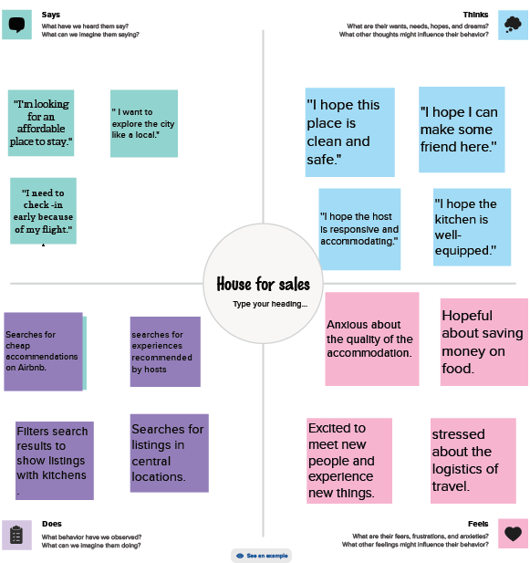

**2.2 Ideation & Brainstorming map**

Group discussion to produce ideas or solve problems.Brainstorming can generate some wonderful ideas.A group problem solving technique that involves the spontaneous contribution of ideas from all members of the group.Property prices in india are expected to increase 7.5% on a pan-india basis this year ,the fastest growth in five years,according to Reuters poll of property analysts.Average house prices were forecast to rise 6% next year and in 2024.The poll of 13 property analysts were held during may 11-27.

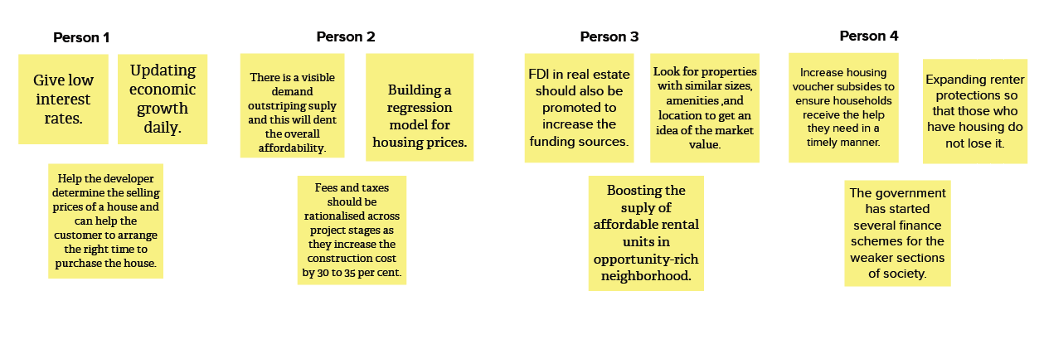

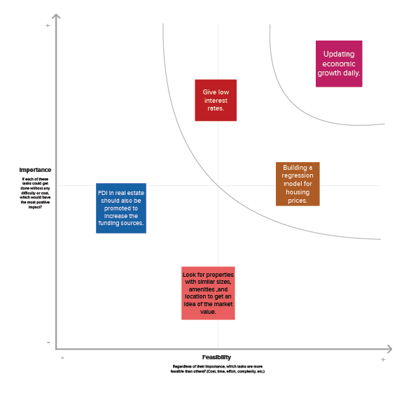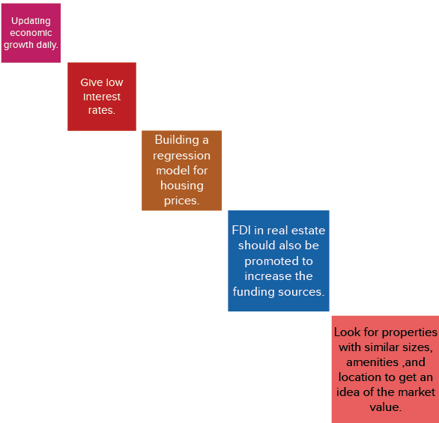

**3.RESULT**

**Final finding(output)**

**Collect the data**

Data collection is the process of gathering and measuring information on variables of interest, in an established systematic fashion that enables one to answer stated research questions, test hypotheses, evaluate outcomes and generate insights from the data.

**Connect Dataset with Tableau**

Download the dataset and connet to the tableau.

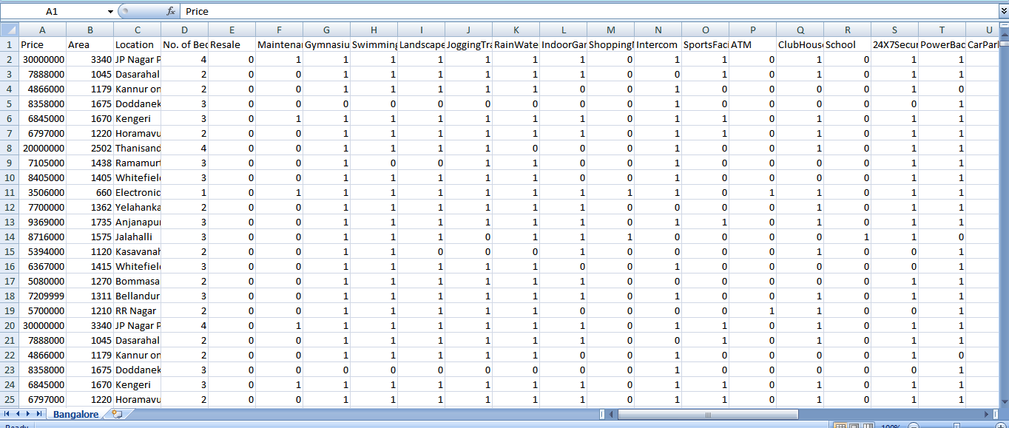

**Data Preparation**

Preparing the data for visualization involves cleaning the data to remove irrelevant or missing data, transforming the data into a format that can be easily visualized, exploring the data to identify patterns and trends, filtering the data to focus on specific subsets of data, preparing the data for visualization software, and ensuring the data is accurate and complete.

This process helps to make the data easily understandable and ready for creating visualizations to gain insights into performance and efficiency.

**Data Visualization**

Data visualization is the process of creating graphical representations of data to help people understand and explore the information. The goal of data visualization is to make complex data sets more accessible, intuitive, and easier to interpret. By using visual elements such as charts, graphs, and maps, data visualizations can help people quickly identify patterns, trends, and outliers in the data.

**Number of unique visualization**

* Latitude and Longitude based on Location
* Number of houses based on area in sqf
* Houses price based on rainwater harvest pits
* Vastu-complains based on location
* House price based on Number of Bedrooms
* Hospitals and schools near the Houses
* Maintains staff in houses prices
* House Price and Intercom
* All Services based on locations

**Dashboard**

A dashboard is a graphical user interface (GUI) that displays information and data in an organized, easy-to-read format. Dashboards are often used to provide real-time monitoring and analysis of data and are typically designed for a specific purpose or use case. Dashboards can be used in a variety of settings, such as business, finance, manufacturing, healthcare, and many other industries. They can be used to track key performance indicators (KPIs), monitor performance metrics, and display data in the form of charts, graphs, and tables.

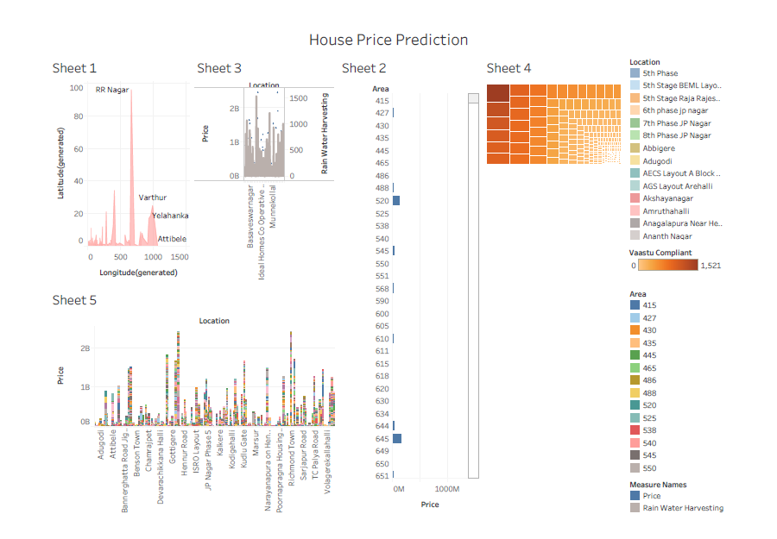

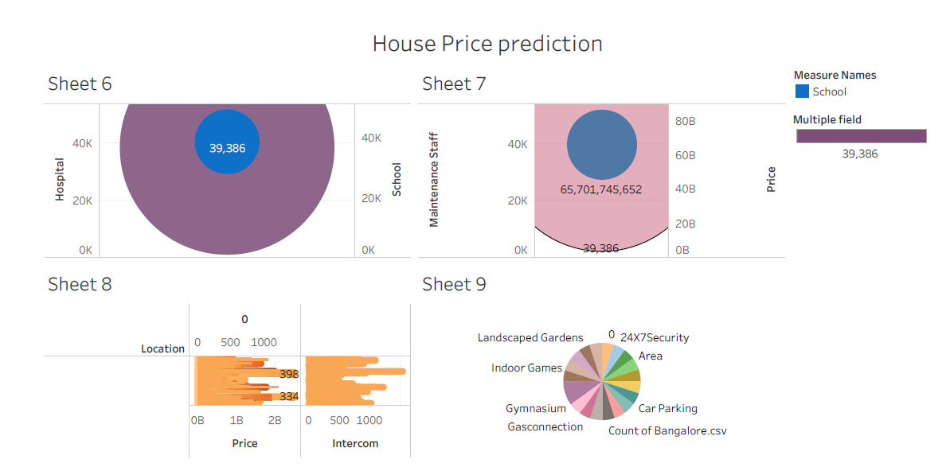

**Story**

A data story is a way of presenting data and analysis in a narrative format, intending to make the information more engaging and easier to understand. A data story typically includes a clear introduction that sets the stage and explains the context for the data, a body that presents the data and analysis logically and systematically, and a conclusion that summarizes the key findings and highlights their implications. Data stories can be told using a variety of mediums, such as reports, presentations, interactive visualizations, and videos.

**Number of Scenes of Story**

The number of scenes in a storyboard for a data visualization analysis of the performance and efficiency of Radisson Hotels will depend on the complexity of the analysis and the specific insights that are trying to be conveyed. A storyboard is a visual representation of the data analysis process and it breaks down the analysis into a series of steps or scenes.

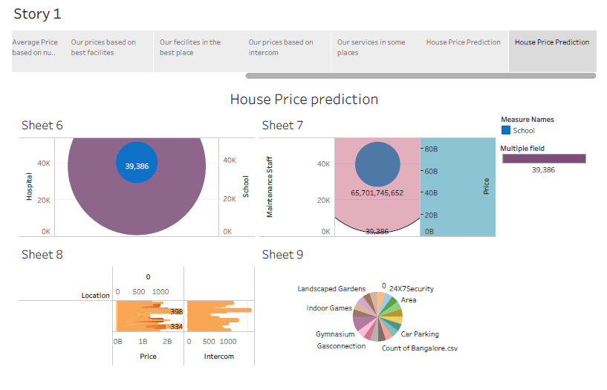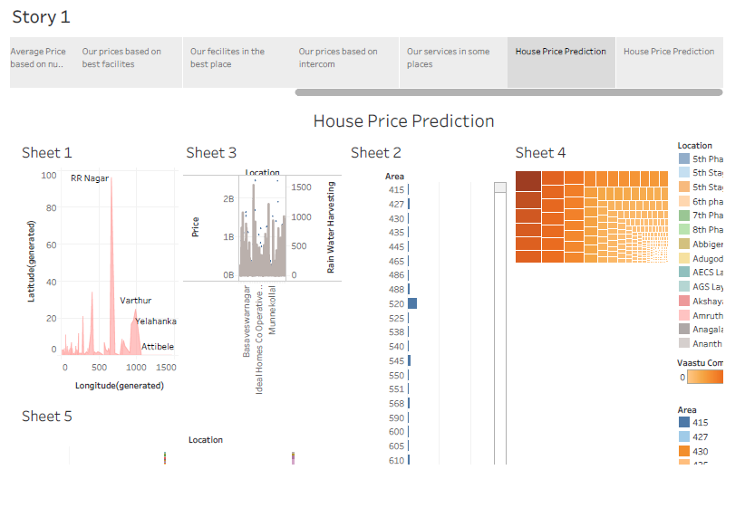

**4. ADVANTAGES**

* The uses of price prediction include increasing customer loyalty and engagement.
* By accurately reflecting the prices of different goods and services using accurate data, customers are more likely to trust the company and its business processes.
* Therefore, price forecasting can **both attract new customers and optimize sales..**
* Entrepreneurs can determine a certain time to invest in businesses and even evaluate the investment value of certain assets.
* Furthermore, price prediction is **perfect for organizations looking to enter a new market or explore a new niche.**

**DISADVANTAGES**

* House price prediction can help the developer determine the selling price of a house and can help the customer to arrange the right time to purchase a house.
* There are three factors that influence the price of a house which include physical conditions, concept and location.
* If sales slow, production rates will naturally follow suit.
* When developers decide to stop building, this has an obvious knock-on effect to the industries that produce house-building materials.
* The ramifications of this will lead to local tradespeople, such as installers, bricklayers and handymen, seeing a drop in business.

**5.APPLICATIONS**

* In addition to pleasing consumers, **price prediction also pleases businesses.** Businesses may use information about prices in a future period to make strategic decisions.
* While some companies believe they have a good understanding of different markets to accurately predict prices themselves, price prediction has its benefits and uses statistically accurate methods.
* The impacts of fluctuating house prices on the construction industry are simple: the more booming the market is, the more the industry will profit.

**6.CONCLUSION**

On the last note, it is important to stress the nature of real estate pricing, which is more an art than an actual science. Just because a house is on the market for a certain price, does not mean that this price is in any way correct. Most house prices are subjectively chosen by real estate agents and/or home owners. It is also very likely that different agents would assign quite different prices for the same estate. Any type of prediction model would have problems to capture this kind of sentiment in the target variable.

**7.FUTURE SCOPE**

In the case of house price prediction, we can use historical data on various features of a house, such as its location, size, and amenities, to train a machine-learning model. Once the model is trained, it can analyze new data on a given house and make a prediction of its market value. Price prediction uses an algorithm to analyze a product or service based on its characteristics, demand, and current market trends. Then the software sets a price at a level it predicts will both attract customers and maximize sales. In some circles, the practice is called price forecasting or predictive pricing.

**8.APPENDIX**

**Source code**

**Data set**

<https://drive.google.com/drive/folders/1pm04WDkkRqK7MefHeybYYszi32puOj7u?usp=sharing>

**Dashboard 1**

<https://public.tableau.com/views/Dashboard1_16957994238130/Dashboard1?:language=en-US&publish=yes&:display_count=n&:origin=viz_share_link>

**Dashboard 2**

<https://public.tableau.com/views/Dashboard2_16957996603350/Dashboard2?:language=en-US&publish=yes&:display_count=n&:origin=viz_share_link>

**Story**

<https://public.tableau.com/views/Story1_16957948069910/Story1?:language=en-US&publish=yes&:display_count=n&:origin=viz_share_link>